**MCS 203 PROJECT: FINAL REPORT**

**‘ANALYSIS OF CRIMES AGAINST WOMEN IN INDIA’**

**PREPARED BY**:

1. Abhishek Sen (M. Sc. Computer Science, Roll No.: 02)
2. Anuradha Aggarwal (M. Sc. Computer Science, Roll No.: 05)
3. Megha Sundriyal (M. Sc. Computer Science, Roll No.: 17)
4. Aanchal Gupta (M.A. Economics, Roll No.: 27003)

**ABSTRACT**

This term paper analyses the dataset for crime rates in India for the year 2001-12 and seeks to find trends of crimes in the various stats/UTs.

**INDEX**

**Sections Page No.**

1. SECTION 1: ABSTRACT…………………………………………………………………………………….2
2. SECTION 2: DATA…………………………………………………………………………………………….2
   * 1. Dataset for Crimes against women
     2. Dataset for population figures from 2001 to 2012
3. SECTION 3: TACKLING QUESTIONS OF INTEREST…………………………………………….3
4. SECTION 4: TRENDS IN CRIME RATES……………………………………………………………..3
   * 1. Why K-means
     2. Finding Optimal Number of Clusters
        + 1. Elbow Method
          2. Silhouette Method
     3. K-means Clustering: Results
5. SECTION 5: RELATION BETWEEN VARIOUS CRIMES……………………………………….8
   * 1. Correlation between the Crimes
     2. Association Rule Mining for Crimes
6. SECTION 6: EXTENSION: PREDICTED CRIMES FOR DELHI FOR 2013-18………….10
7. SECTION 7: CONCLUSION……………………………………………………………………………..12
8. APPENDIX……………………………………………………………………………………………………..14
   * 1. Appendix A1
9. **OBJECTIVE**

The aim of the project is to analyze the trends of crimes against women across various states and union territories over a twelve year period of 2001-12. The project strives to uncover if there is has been any rise or fall or whether there is some other discernible pattern in the crime rates.

1. **DATA**
2. Dataset for Crimes against women

The open government data (OGD) platform www.data.gov.in was used to look for relevant datasets. The dataset which was narrowed down is a panel dataset provided by National Crime Records Bureau (NCRB), Ministry of Home Affairs. For a twelve year period, from 2001 to 2012, the dataset has number of crimes committed against women in each year in the 35 States and Union Territories (UTs). There are eight crimes against women which our dataset recognizes.

The data set is organized as follows:

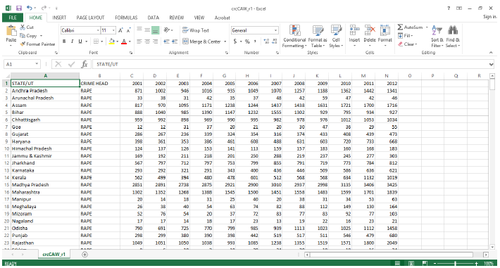

The crimes reported for all the states and UTs in the dataset are as follows:

1. Rape
2. Assault on women with intent to outrage her modesty
3. Cruelty by husband or relative
4. Dowry death
5. Immoral traffic (prevention) act
6. Indecent representation of women (prevention) act
7. Insult to the modesty of women
8. Kidnapping and abduction

The dataset, by virtue of it being extensive in coverage of different kinds of crimes over a long span of time, made a convincing case to be selected for the purpose of analyzing trends.

1. Dataset for population figures from 2001 to 2012

The dataset selected with figures on crimes against women simply provides the absolute numbers of the crimes reported against women. Absolute numbers, although good enough for some visualization exercises, don’t yield reasonable results when one has to compare them across objects. For example, comparing the absolute number of crimes committed in Uttar Pradesh should not be compared with the respective figure reported by a state like Arunachal Pradesh. This is because Uttar Pradesh by virtue of being the most populous state is likely to report higher absolute crime rates than a state like Arunachal Pradesh which is sparsely populated. Hence, comparing relative figures would make more sense.

This problem was tackled by weighting crime rates by the respective female-population projection figures of the states and UTs. The population projection figures used for this purpose were taken from the report submitted in 2006 by the technical group on population projections constituted by the National Commission on Population. Resulting figures may be interpreted as ‘Uttar Pradesh reports a crime rate of 12.4 per lakh women’.

1. **TACKLING THE QUESTIONS OF INTEREST**

Our aim, as already outlined in the proposal, is to conduct a data mining exercise with an objective to seek answers to the following questions:

i) What is the year on year trend of crimes for each state?

ii) Does there exist any relation between any two kinds of crimes reported? For example, can we say that the trends of kidnapping and abduction move in a similar manner to trends in trafficking of women?

iii) Can the data be used to predict the crime rates for a state/UT?

The answers to above questions are discussed in the sections which follow. The methodology used for the purpose of analysis is also provided along with brief comments on results.

1. **TRENDS IN CRIMES RATES**

Before weighting the crime rates for all states and UTs over the entire time period, a small exercise was done on the crime rates of year 2001 alone. The weighted figures of crime rates when plotted according to crimes revealed that the data could in fact be potentially clustered, where the clusters containing the states/UTs according to frequency of crimes committed per lakh women. The graphs are presented in Appendix 1. This analysis was followed up: crime rates for all states/UTs were weighted with the respective projected population of females for the entire period of 12 years viz. 2001-12. After this, K-means clustering algorithm was used to cluster the states.

1. Why K-means?

K-means clustering is a type of unsupervised learning, which is used when you have unlabeled data (i.e., data without defined categories or groups). The goal of this algorithm is to find groups in the data, with the number of groups represented by the variable K. The algorithm works iteratively to assign each data point to one of K groups based on the features that are provided. Data points are clustered based on feature similarity. We used this simple yet effective method to cluster our data. We expect states to be clustered according to similar crime rates in that particular year.

1. Finding Optimal Number of Clusters

One of the inputs in the algorithm of K-means is the number of clusters. Theoretically, a cluster comprises of all the data-points that are ‘similar’ to each other. By implication, optimal number of clusters are obtained when the distance between data-points in a cluster is minimized while the distance between clusters is maximized. Hence, the goal is to find a clustering scheme for which sum of squared errors SSE(C) is minimized. i.e. Find clustering scheme C* such that,

C*=

where, SSE(C)=2

We use two methods of finding the optimal number of clusters for our analysis. They are:

1. Elbow Method

This method looks at the percentage of variance explained as a function of the number of clusters: One should choose a number of clusters so that adding another cluster doesn't give much better modeling of the data. More precisely, if one plots the variance explained by the clusters against the number of clusters, the first clusters will add much information (explain a lot of variance), but at some point the marginal gain will drop, giving an angle in the graph. The number of clusters where this ‘elbow’ occurs gives us the optimal number of clusters. We do this for the crime rates in year 2012. The graph 4.1 below shows the result.

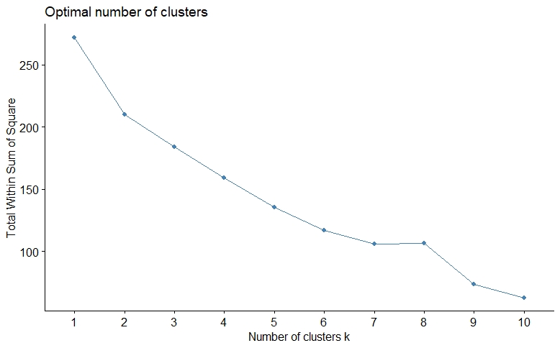

Graph 4.1: Optimal number of clusters using Elbow Method

From the above graph we observe that the ‘break’ seems plausible at two points: k=2 and k=8. To reinforce our results, we use Silhouette method of finding optimal number of clusters. The same has been elucidated below.

1. Silhouette Method

The silhouette value is a measure of how similar an object is to its own cluster (cohesion) compared to other clusters (separation). The silhouette ranges from −1 to +1, where a high value indicates that the object is well matched to its own cluster and poorly matched to neighboring clusters. If most objects have a high value, then the clustering configuration is appropriate. If many points have a low or negative value, then the clustering configuration may have too many or too few clusters. Thus, optimal k is where silhouette value is maximized. We present result for the crime rates of 2012 in the following graph. We see that, like the elbow method also depicted, the optimal value of k comes out to be 2. This is because the silhouette value peaks at k=2.

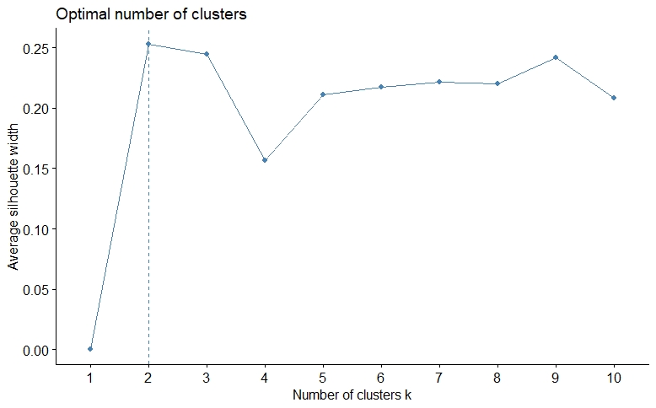

Graph 4.2: Optimal number of clusters using Silhouette Method.

Thus, we do the clustering analysis with k=2.

1. K-means Clustering: Results

As explained above, use the K-means clustering algorithm with the number of clusters equal to two. Cluster 1 indicates a relatively low level of crime while Cluster 2 indicates a relatively higher level of crimes. The graphs showing clusters are presented below for years 2001, 2003, 2006, 2009, and 2012.

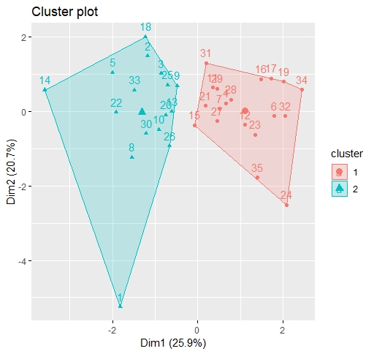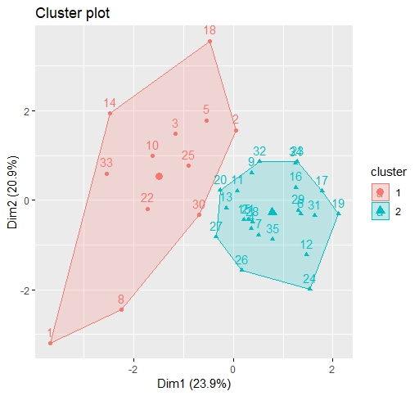

Cluster Plot for 2003

Cluster Plot for 2001

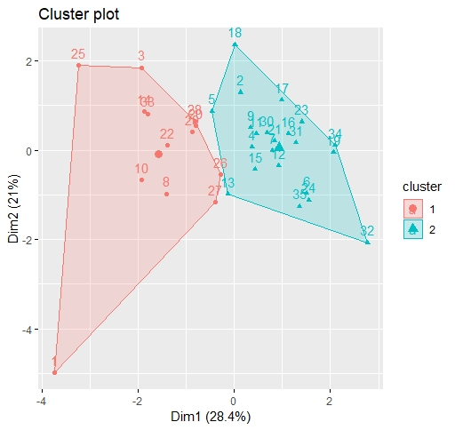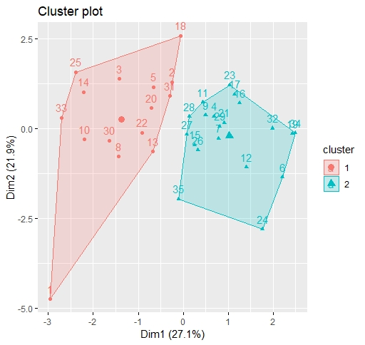

Cluster Plot for 2009

Cluster Plot for 2006

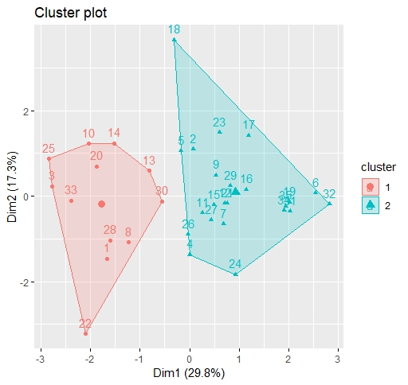

Cluster Plot for 2012

To see the movements of states across clusters over the years, we use the following table

|  |  |  |  |  |  |  |
| --- | --- | --- | --- | --- | --- | --- |
| S. No. | States | 2001 | 2003 | 2006 | 2009 | 2012 |
| 1 | Andhra Pradesh | 1 | 1 | 1 | 1 | 1 |
| 2 | Arunachal Pradesh | 1 | 1 | 1 | 2 | 2 |
| 3 | Assam | 1 | 1 | 1 | 1 | 1 |
| 4 | Bihar | 2 | 2 | 2 | 2 | 2 |
| 5 | Chhattisgarh | 1 | 1 | 1 | 2 | 2 |
| 6 | Goa | 2 | 2 | 2 | 2 | 2 |
| 7 | Gujarat | 2 | 2 | 2 | 2 | 2 |
| 8 | Haryana | 1 | 1 | 1 | 1 | 1 |
| 9 | Himachal Pradesh | 1 | 2 | 2 | 2 | 2 |
| 10 | Jammu & Kashmir | 1 | 1 | 1 | 1 | 1 |
| 11 | Jharkhand | 2 | 2 | 2 | 2 | 2 |
| 12 | Karnataka | 2 | 2 | 2 | 2 | 2 |
| 13 | Kerala | 1 | 2 | 1 | 2 | 1 |
| 14 | Madhya Pradesh | 1 | 1 | 1 | 1 | 1 |
| 15 | Maharashtra | 2 | 2 | 2 | 2 | 2 |
| 16 | Manipur | 2 | 2 | 2 | 2 | 2 |
| 17 | Meghalaya | 2 | 2 | 2 | 2 | 2 |
| 18 | Mizoram | 1 | 1 | 1 | 2 | 2 |
| 19 | Nagaland | 2 | 2 | 2 | 2 | 2 |
| 20 | Odisha | 1 | 2 | 1 | 1 | 1 |
| 21 | Punjab | 2 | 2 | 2 | 2 | 2 |
| 22 | Rajasthan | 1 | 1 | 1 | 1 | 1 |
| 23 | Sikkim | 2 | 2 | 2 | 2 | 2 |
| 24 | Tamil Nadu | 2 | 2 | 2 | 2 | 2 |
| 25 | Tripura | 1 | 1 | 1 | 1 | 1 |
| 26 | Uttar Pradesh | 1 | 2 | 2 | 1 | 2 |
| 27 | Uttarakhand | 2 | 2 | 2 | 1 | 2 |
| 28 | West Bengal | 2 | 2 | 2 | 1 | 1 |
| 29 | A&N Islands | 2 | 2 | 2 | 1 | 2 |
| 30 | Chandigarh | 1 | 1 | 1 | 2 | 1 |
| 31 | D&N Haveli | 2 | 2 | 1 | 2 | 2 |
| 32 | Daman & Diu | 2 | 2 | 2 | 2 | 2 |
| 33 | Delhi UT | 1 | 1 | 1 | 1 | 1 |
| 34 | Lakshadweep | 2 | 2 | 2 | 2 | 2 |
| 35 | Puducherry | 2 | 2 | 2 | 2 | 2 |

Table 4.1: Movements of States across clusters over the years.

From the table we observe that there are certain states/UTs which have consistently belonged in the cluster which denoted higher level of crime rates across all years. These states are: Bihar, Goa, Gujarat, Jharkhand, Karnataka, Maharshtra, Manipur, Meghalaya, Nagaland, Punjab, Sikkim, Tamil Nadu, Daman and Diu and Pondicherry. Some states/UTs have consistently performed well and have belonged to the cluster which denoted lower levels of crime rates. These states are: Andhra Pradesh, Assam, Jammu & Kashmir, Madhya Pradesh, Tripura and Delhi. These results may seem surprising, however, one must keep in mind that we are doing relative comparison. Lower level of crimes for many states/UTs may itself be high in absolute terms. While the consistent performers are quite many, there are states which have improved such as West Bengal while many states and UTs have regressed from cluster 1 (low level of crime) to cluster 2 (high level of crime). These are: Chhattisgarh, Mizoram and Uttar Pradesh.

1. **RELATION BETWEEN VARIOUS CRIMES**
   * 1. Correlation between the crimes

A-priori we expect certain crimes to be correlated. For example, we expect the instances of rapes to be correlated with instances of crimes reported under ‘assault on women with intent to outrage her modesty’. We make use of Spearman’s rank correlation coefficient between the different crimes reported. To ease the presentation of tables, we use the following labels for crimes:

|  |  |
| --- | --- |
| **Crime** | **Label** |
| Rape | C1 |
| Kidnapping & Abduction | C2 |
| Dowry Death | C3 |
| Assault On Women With Intent To Outrage Her Modesty | C4 |
| Insult To The Modesty Of Women | C5 |
| Cruelty By Husband Or Relatives | C6 |
| Immoral Traffic(Prevention)Act | C7 |
| Indecent Representation Of Women(Prevention)Act | C8 |

Table 5.1: Labels for the crimes used in tables

The Spearman’s Rank Correlation Coefficient is found out for the eight crimes labeled as C1, C2,…, C8. The results of correlation coefficients are provided in the table below:

|  |  |  |  |  |  |  |  |  |
| --- | --- | --- | --- | --- | --- | --- | --- | --- |
|  | **C1** | **C2** | **C3** | **C4** | **C5** | **C6** | **C7** | **C8** |
| **C1** | 1.00 | 0.90 | 0.85 | 0.74 | 0.55 | 0.81 | 0.84 | 0.92 |
| **C2** | 0.90 | 1.00 | 0.88 | 0.79 | 0.58 | 0.76 | 0.90 | 0.90 |
| **C3** | 0.85 | 0.88 | 1.00 | 0.72 | 0.46 | 0.75 | 0.86 | 0.90 |
| **C4** | 0.74 | 0.79 | 0.72 | 1.00 | 0.60 | 0.74 | 0.71 | 0.68 |
| **C5** | 0.55 | 0.58 | 0.46 | 0.60 | 1.00 | 0.44 | 0.48 | 0.50 |
| **C6** | 0.81 | 0.76 | 0.75 | 0.74 | 0.44 | 1.00 | 0.71 | 0.71 |
| **C7** | 0.84 | 0.90 | 0.86 | 0.71 | 0.48 | 0.71 | 1.00 | 0.88 |
| **C8** | 0.92 | 0.90 | 0.90 | 0.68 | 0.50 | 0.71 | 0.88 | 1.00 |

Table 5.2: Spearman’s Rank Correlation between various crimes

It is noteworthy that if we use the thumb-rule outlined in the following table:

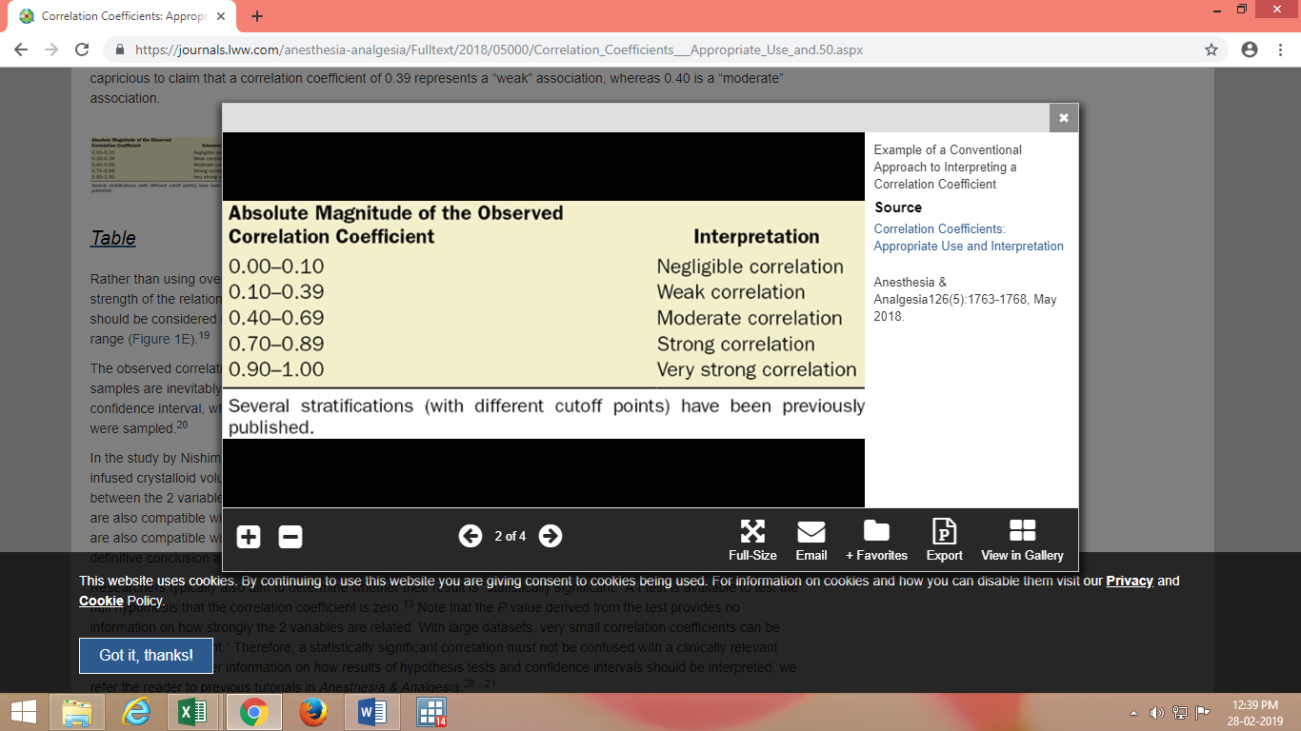

Table 5.3: Thumb-rule for strength of correlation.

It can be concluded that there exists a ‘strong correlation’ in many of the pairwise crimes considered, hence reaffirming our a-priori expectations. The values highlighted in table 5.2 denote high correlation between the respective crimes. For example, Rape and Kidnapping & Abduction are very strongly correlated with the rank correlation coefficient equal to 0.9! Other values can be interpreted likewise.

* + 1. Association Rule Mining for Crimes

Rules generation can be done by association rule mining with the help of support and confidence. If there is an expression in the form of X U Y, where X and Y are disjoint datasets, then Support determines how often a rule is applicable to a given dataset and Confidence determines how frequently items in Y appear in transactions that contain X. We have:

Support, S(X UY) = support (X U Y) / N

Confidence, C(X U Y) = support (X U Y) / support (X)

Association rule mining is a technique to identify underlying relations between different items. Usually, there is also a pattern in how the crimes take place. For instance, states that reported a high number of indecent behavior against women, also reported high number of assault cases. In short, crime reported involve a pattern.

Assuming Confidence threshold to be 70%, following association rules are found:

{indecent}-> {assault},

{indecent} -> {cruelty},

{cruelty, indecent} -> {assault},

{assault, indecent} -> {cruelty},

{indecent} -> {assault, cruelty},

{assault, dowry} -> {rape},

{assault, kidnap} -> {rape},

{dowry, insult} -> {cruelty},

{cruelty, insult} -> {dowry},

{insult, rape} -> {cruelty},

{cruelty, kidnap} -> {rape},

{insult, rape} -> {dowry}]

These can we interpreted as:

1. If indecent then assault
2. if indecent then cruelty
3. if cruelty and indecent then assault

and so on...

Using these patterns, it can be easily seen that certain crimes are associated and how preventing one can reduce the number of cases of other associated crime. For instance, if crime A and B occur together more frequently then several steps can be taken to decrease the number of cases of A and by consequence B.

1. **EXTENSION: PREDICTED CRIMES FOR DELHI FOR 2013-18**

As an extension to our analysis, we use simple linear regression to predict the crime rates for Delhi for the time period of 2013-18. We observe an increasing trend in almost all the crimes for the five year period under consideration. Projected Kidnapping and Abduction, for example, are predicted to increase at a steep rate. A similar, steep trend is also observed for the crime cruelty by husbands and relatives. For crimes such as indecent representation of women the trend line and predicted values lie on a flat line, while immoral trafficking is expected to go down. The total crime rates are predicted to shoot up in Delhi during 2013-18. The graphs presented below can be referred for further scrutiny.

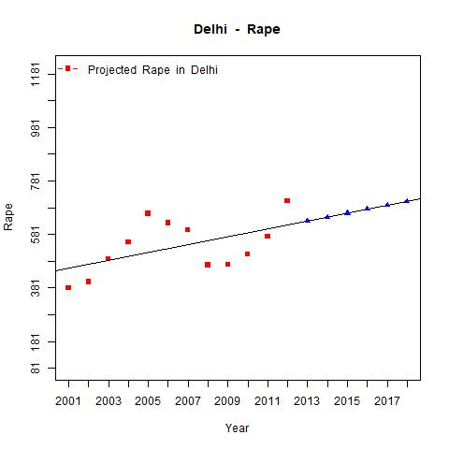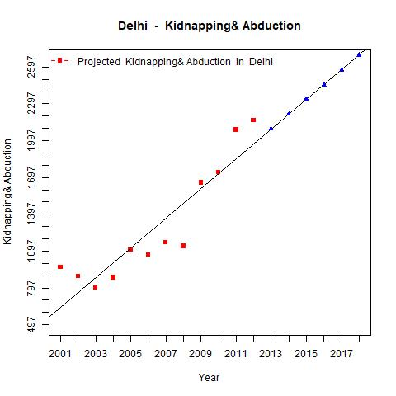

Predicted values of Kidnapping and Abduction for Delhi show an, steep & increasing trend over the years 2013-18

Predicted values of Rape for Delhi show an increasing trend over the years 2013-18

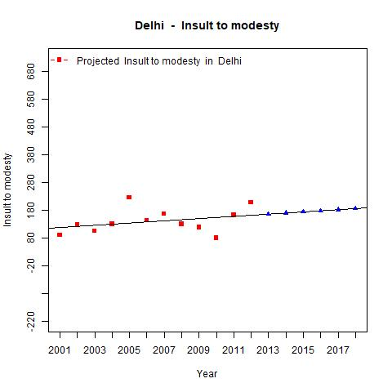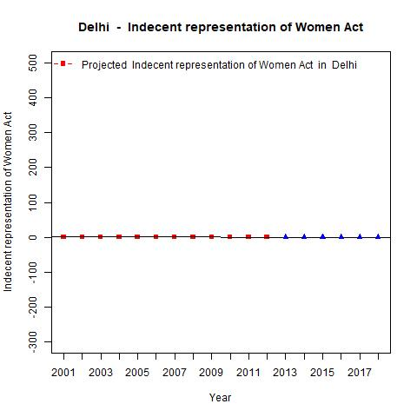

Predicted values of Indecent Representation of Women for Delhi show an, steep & increasing trend over the years 2013-18

Predicted values of Insult to modesty of women for Delhi show a slightly increasing trend over the years 2013-18

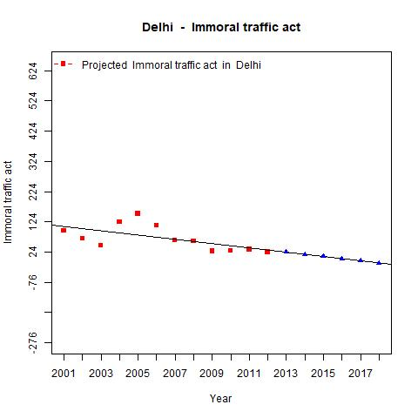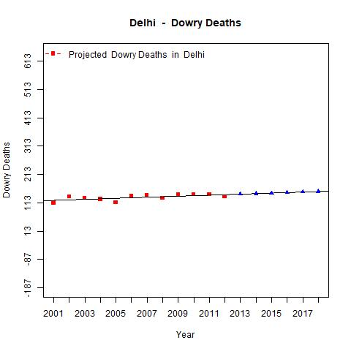

Predicted values of Immoral Trafficking of Women for Delhi show a declining trend over the years 2013-18

Predicted values of Dowry Deaths of Women for Delhi show a slightly increasing trend over the years 2013-18

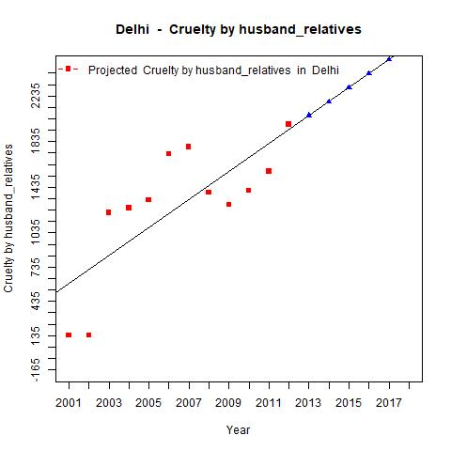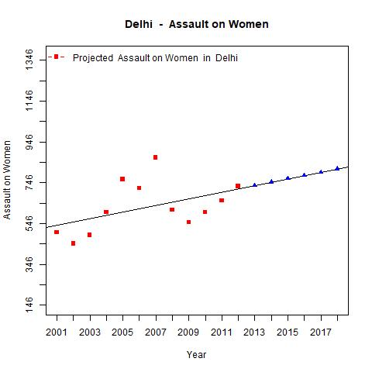

Predicted values of Assault on Women for Delhi show an increasing trend over the years 2013-18

Predicted values of Cruelty on women by husband/relatives in Delhi show a declining trend over the years 2013-18

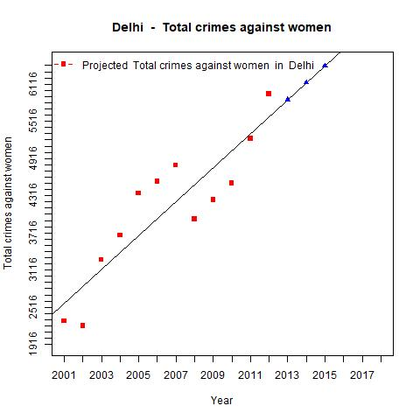

Predicted values of overall crimes against women for Delhi show a steep and increasing trend over the years 2013-18

1. **CONCLUSION**

The main aim of this project was to analyze the trends in crime rates for various states and UTs of India for 2001-12. The results show that certain states have improved the pattern of crime rates but for most states the pattern seems to be an upward sloping, steep graph. This is an alarming issue for us as a society as women constitute 50% of the society we live in. Further, addressing the fact that crimes may be correlated, and that making efforts in reducing one crime may implicitly cause another crime to decline, we used Apriori Algorithm with association rule mining to show the probability of relationships between different crime heads. We find evidence that there in fact exists a significant relationship between certain crimes. Efforts in reducing a typical crime may be leveraged to reduce other related crimes as well. Along with the present scope of our project, which is analysis of the crime against women in India, we also predicted the crime rate for Delhi for 2013-18. The results show us that most of the crimes are expected to increase in Delhi in the years under consideration.

**APPENDIX**

**APPENDIX 1:**

The following six graphs in this appendix were plotted to see the instances of crimes per lakh women for each state/UT in the year 2001.

